**ArchiCAD Windows (Automatic installation):**  
  
1. Download the addon.  


2. Open the file.

3. Click “Run anyway”

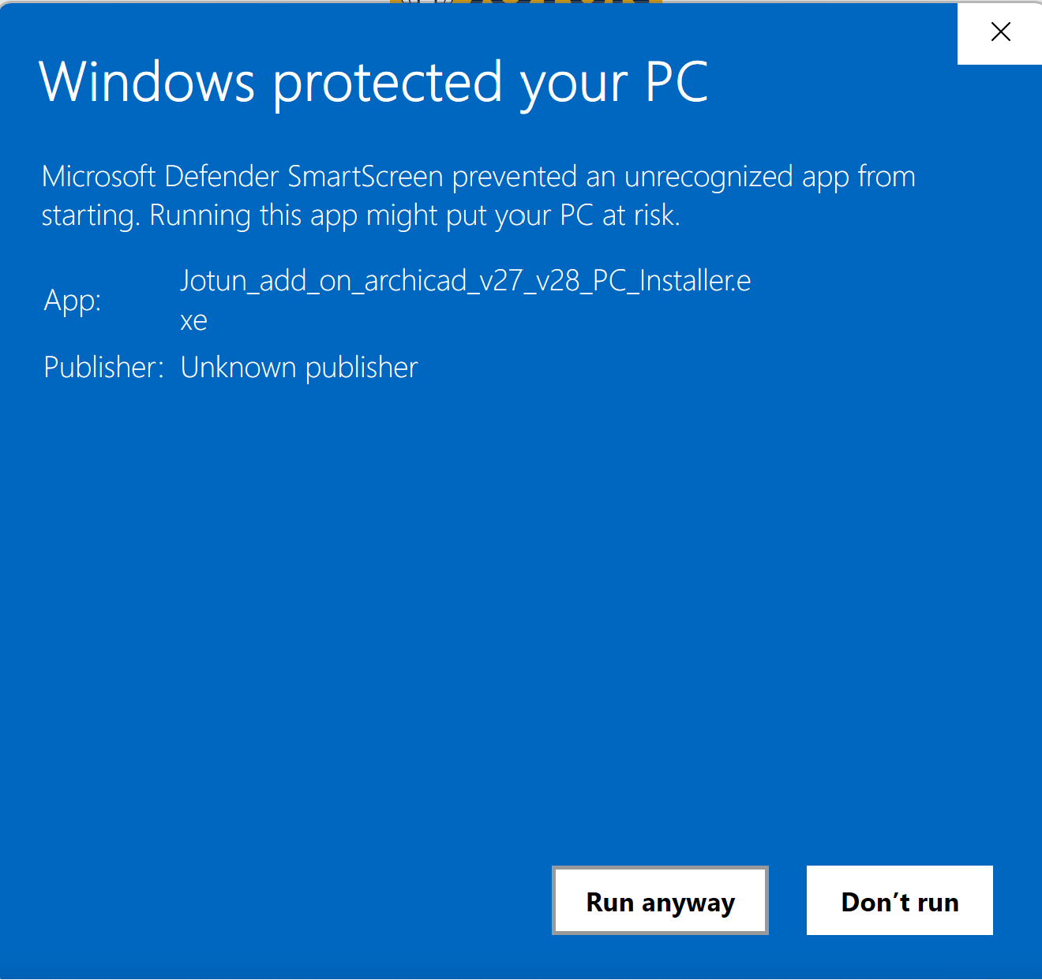

4. Click “Next”.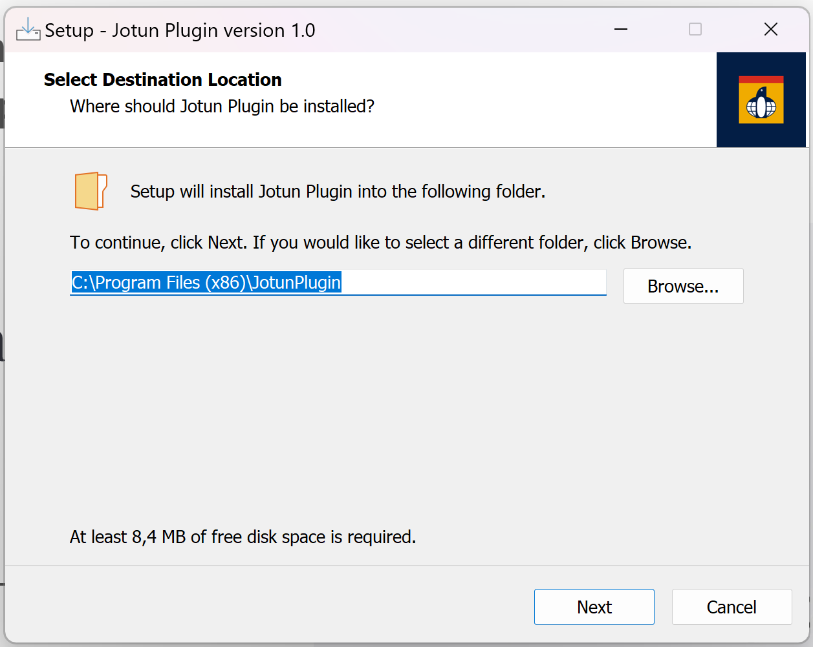

5. Check the corresponding boxes to which version of ArchiCAD you have installed and click “Next”.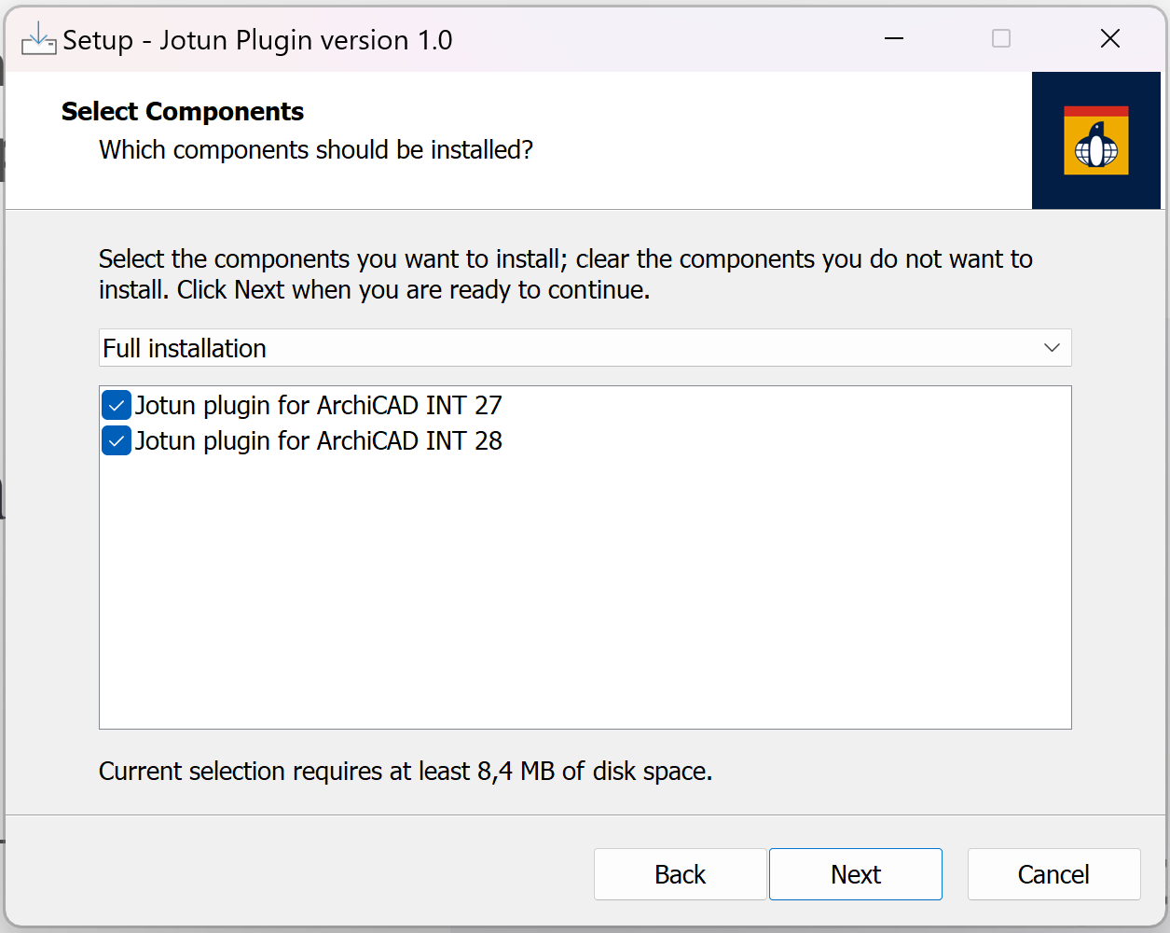

6. Click “Finish”.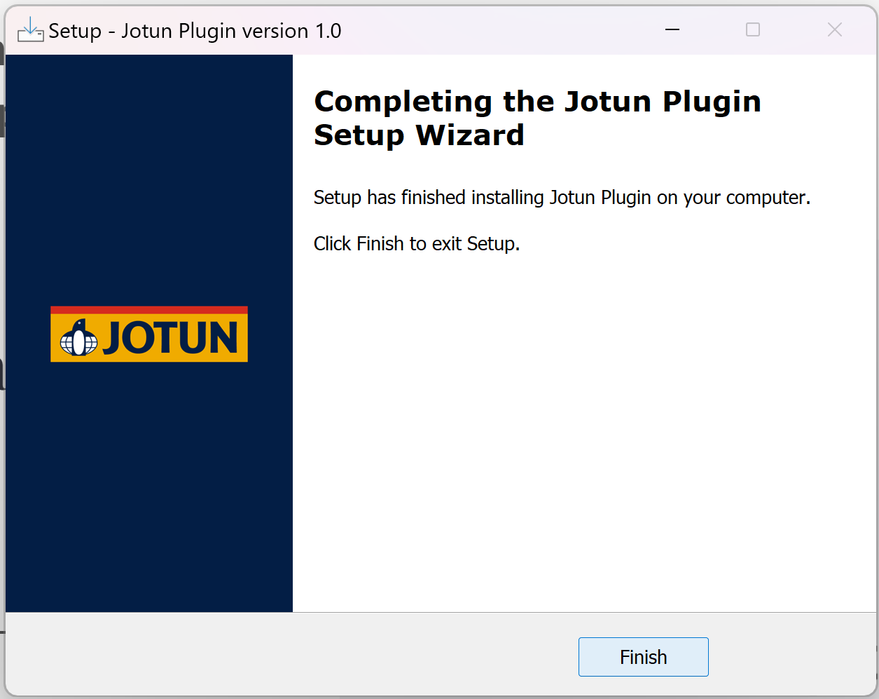

7. Open ArchiCAD and you should see the addon in the top menu bar.

