**ArchiCAD Windows (Manual installation):**  
  
1. Download the addon.  


2. Extract the file.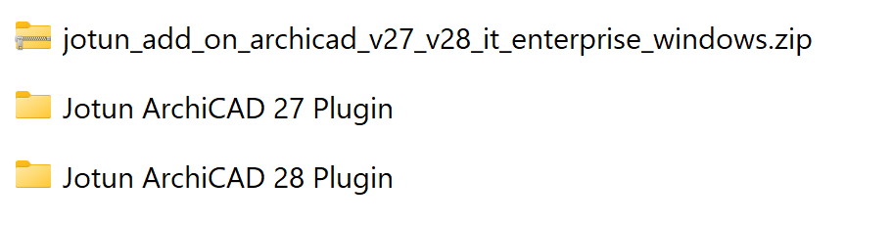

3. You can now delete the .zip file.

4. It's recommended to not store them in the Downloads folder as it's easy to accidentally delete them. You can move them to a new folder, ex. “Documents/Jotun plugins”.

5. Open ArchiCAD.

6. Open a project.

7. Open Addon Manager.  
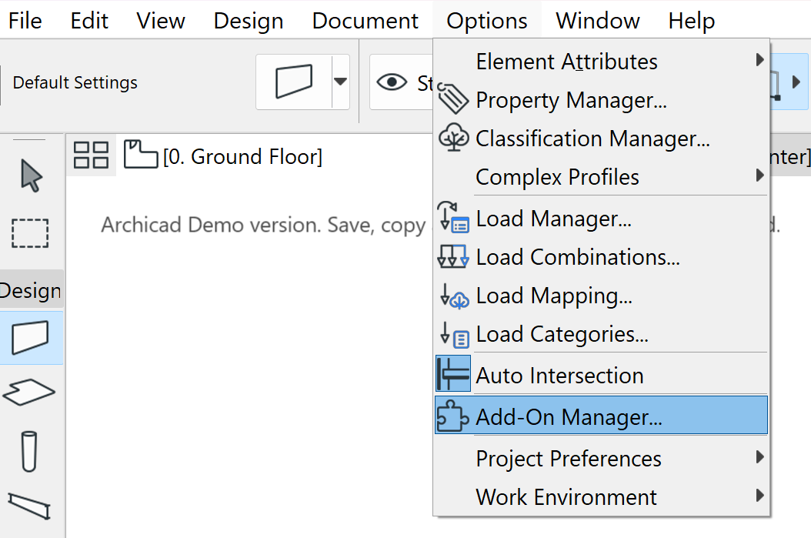

8. Expand the “EDIT LIST OF AVAILABLE ADD-ONS” and click “Add…”.  
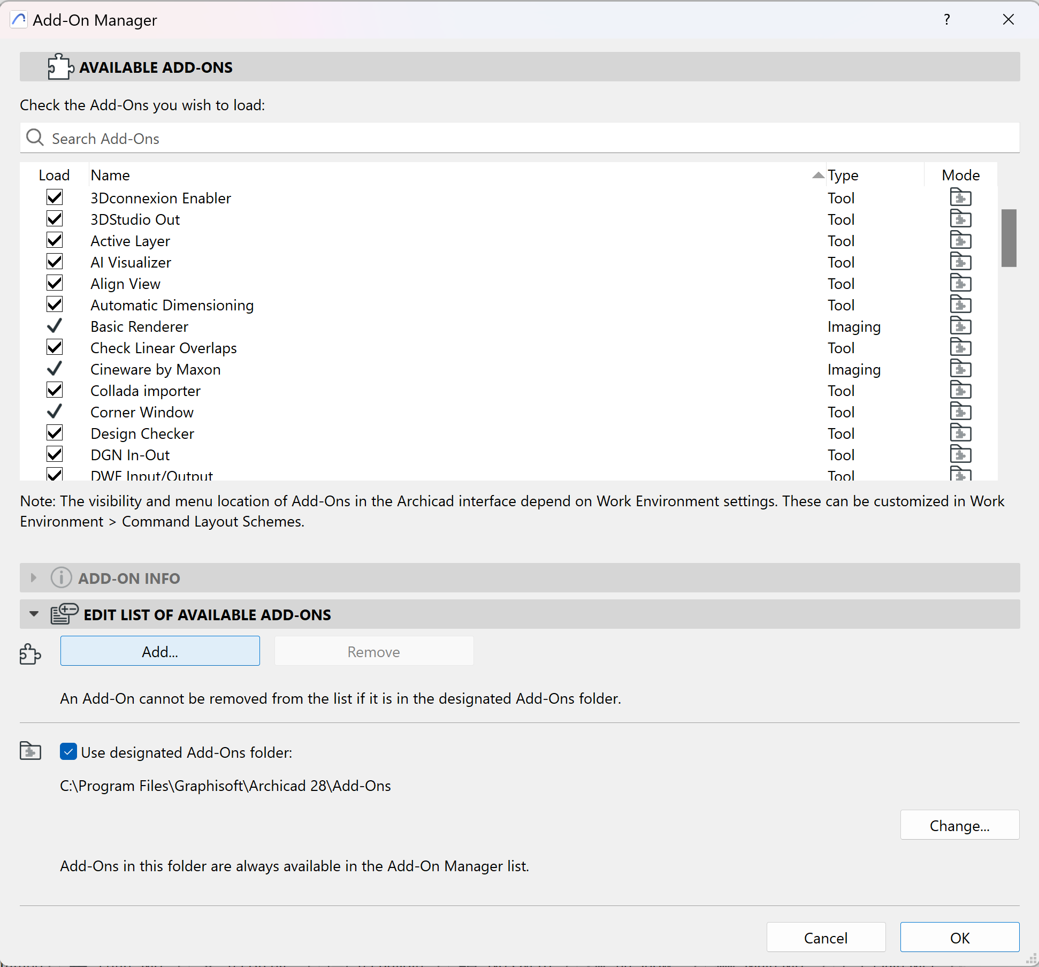

9. Find the addon and click “OK”.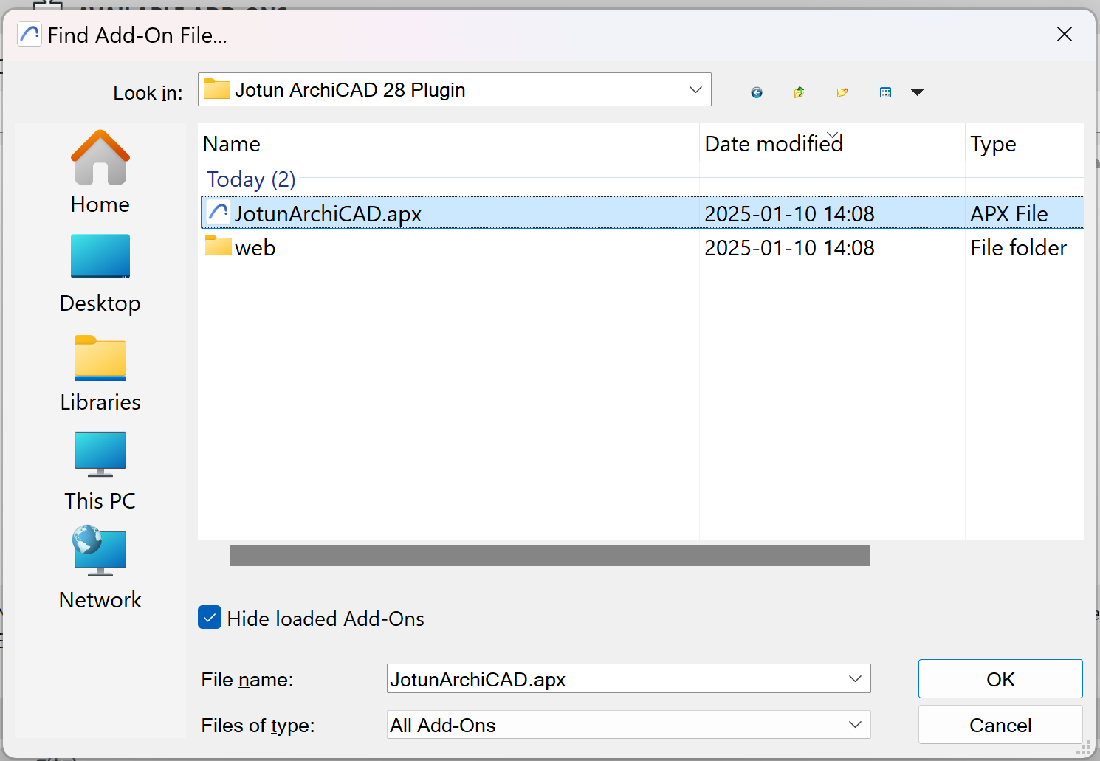

10. Make sure it is loaded.

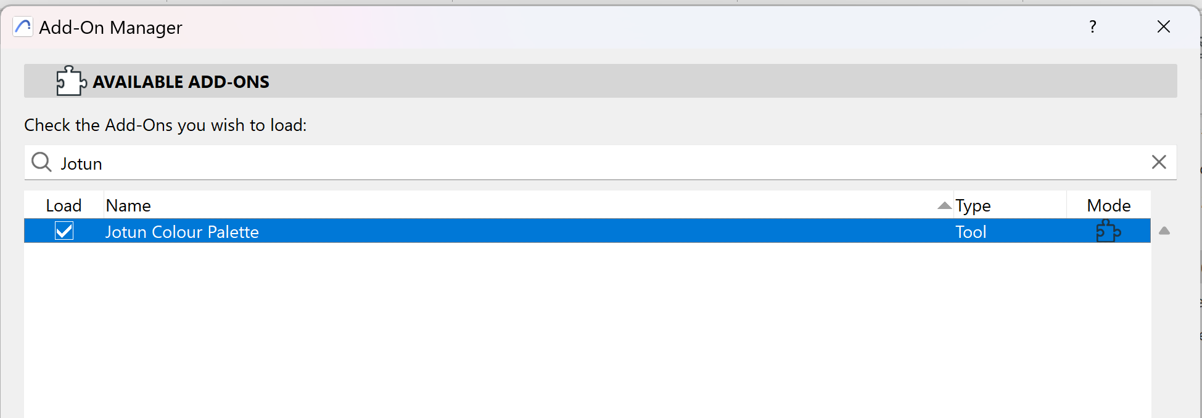

11. Click OK.

12. Make sure you do not have any unfinished changes.

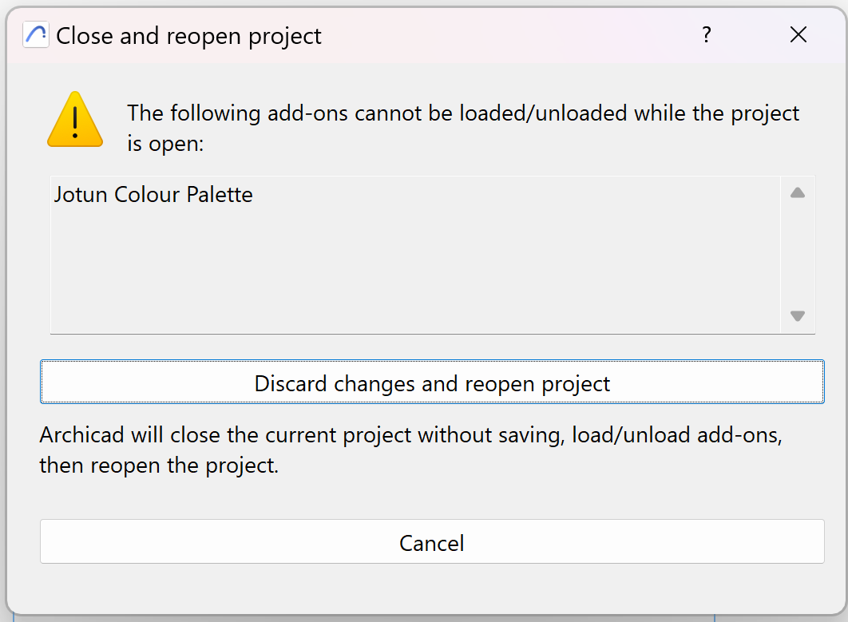

13. Open up a new project.

14. You should see the addon in the top menu bar.

